Yuyi Zhang
Oct 24, 2020
Fall 2020 CPS Quarter
Instructor: Dr. Steward Huang
Module 6:
Collaborative Project -
Heart Disease
ALY 6020_Predictive Analytics

Introduction
In this report, we are going to go through the heart disease data set and classify the result of diagnosis by three different algorithms: Decision trees, Random forest, and Logistic model. The Decision Trees build flowchart structures. The Random forests are made out of decision trees. It combines the simplistic of Decision trees with flexibility resulting in vast improvement in accuracy. Logistic model belongs to generalized linear model (GLM) family. It predicts True or False for the target variables rather than general linear models. We are going to train these three models and compare their performance.

Method
Import the data and take a look at the first 6 rows.
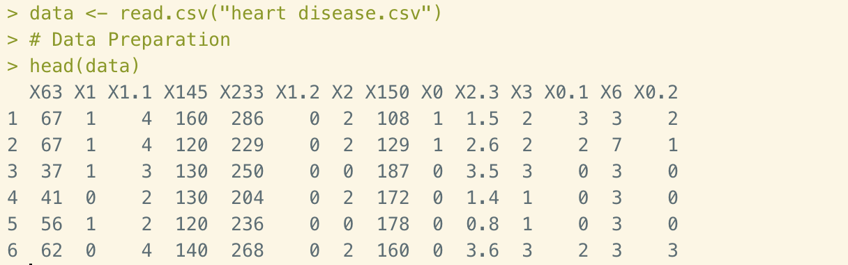
Figure 1. Importing data and first rows
As we can see that none of the columns are labeled. So we need to name the columns and bring out the head function again.
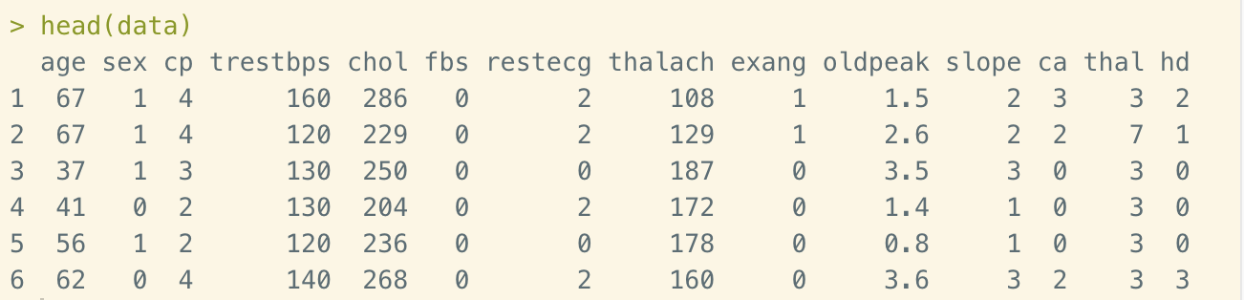
Figure 2. Adjusted first 6 rows
Now this looks much easier. From the variables we could see that the absolute numbers of each column could be very different from others. Especially there are many “0”s in some of the columns. This is not easy for k-NN since we need to normalize the numeric data. The Naïve Bayes is more focus on text content rather than numeric data. Thus in this case, we are going to use Decision tree, Random forest and Logistic model to solve the prediction of heart disease.

Analysis
Before we dive into the model generating, let’s first clean up the data. The structure of data is shown as below.
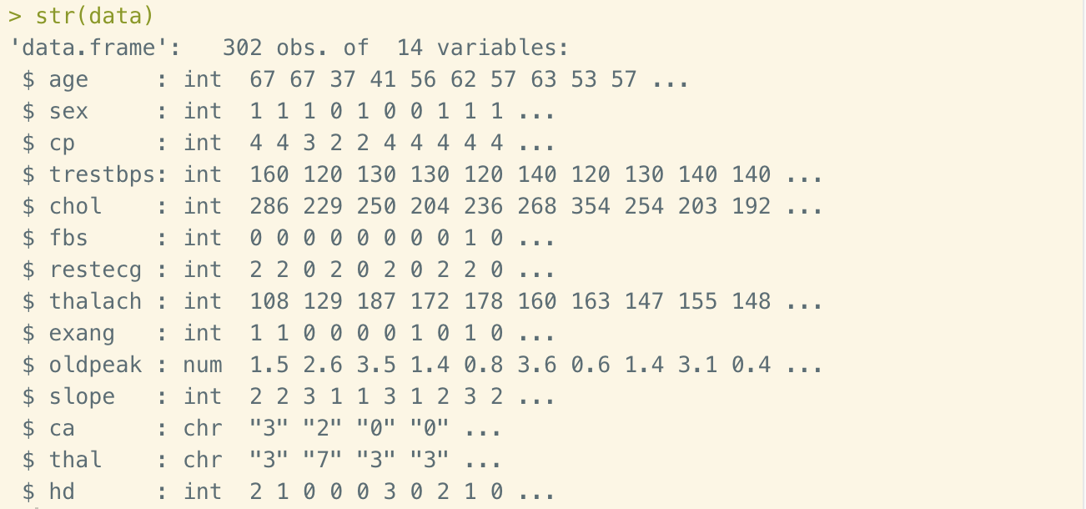
Figure 3. Structure of data
Now let’s convert all the “?” to “NA”s and convert variables to factor levels.
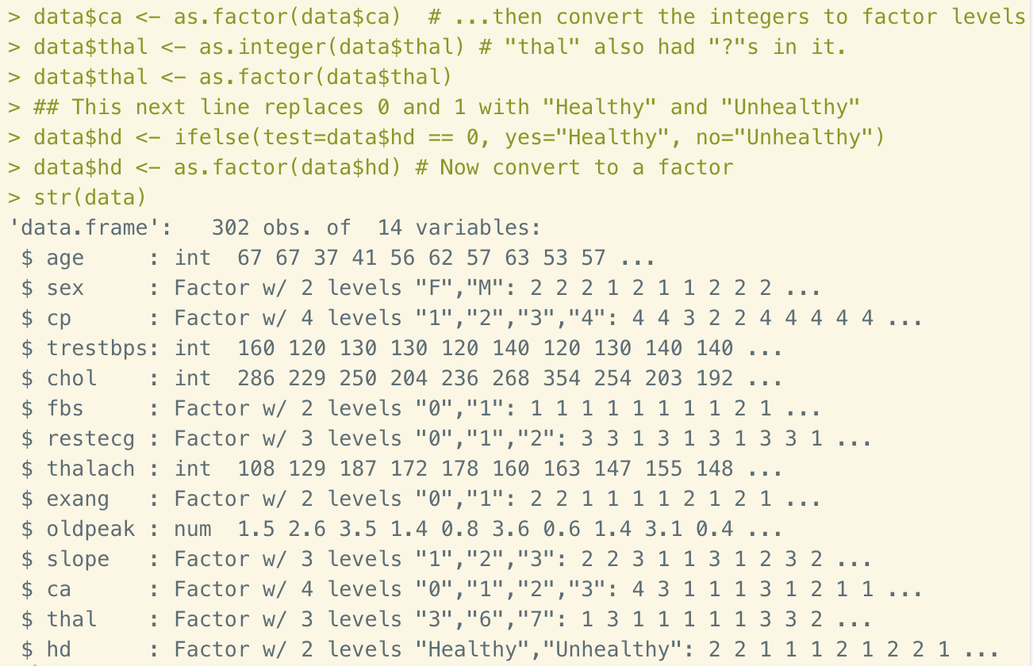
Figure 4. Adjusted structure of data
Next we will check out how many rows have “NA”s. If the number of missing data is not large, then we could simply delete them.
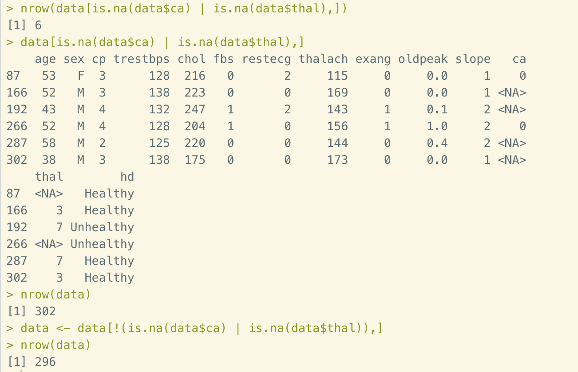
Figure 5. Checking out the missing data
Last step of data cleaning is to check out the bias.
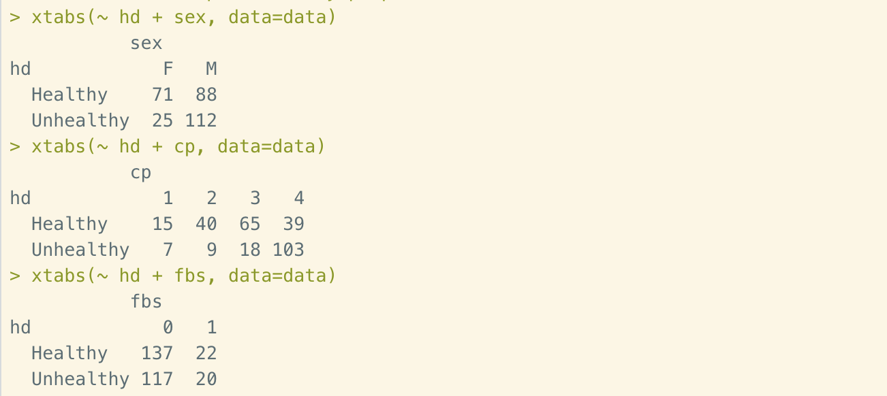
Figure 6. Checking for bias
This is a step of quality control. We want to make sure that all of the factor levels are represented by people with and without heart disease.

Decision Tree

Step 1 – creating random training and test datasets
To make sure that all observations in this dataset are randomly ordered, we split the data into training data and test data by sample() function. Then use 90% of the entire dataset as training data and 10% of test data. we also need to check out the portion of default observations in both datasets.
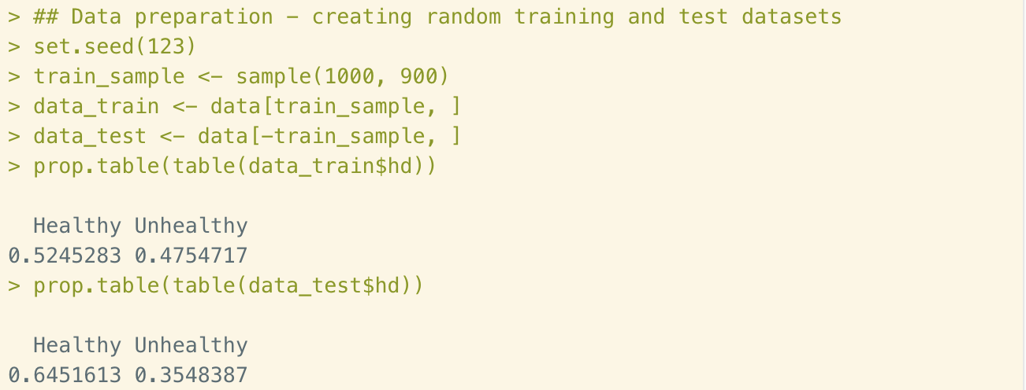
Figure 7. Dividing dataset into training data and test data
As we can see that in training dataset, the portion of Healthy and Unhealthy are close to even. So, our training data set are ready to use.

Step 2 – training a model on the data
In this step, we are going to train our decision tree model using C5.0 algorithm using all columns, except the target variable on the last column.
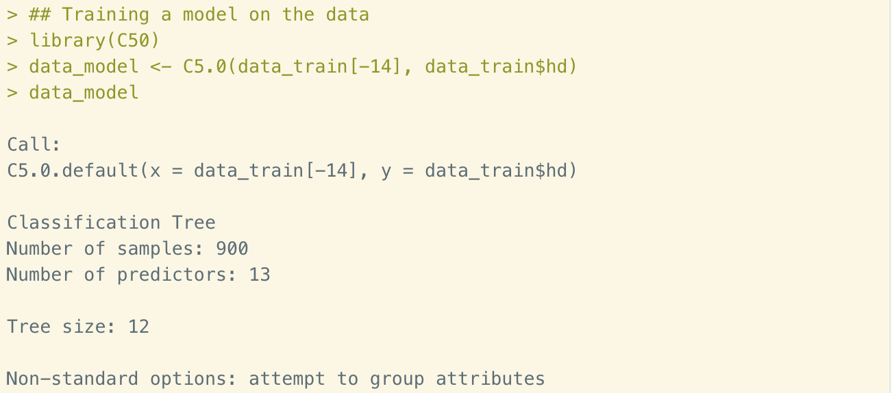
Figure 8. Train the decision tree model
From this page we could see that the tree size of this model is 12, which is not large. Then let’s get more detail information from summary() function.
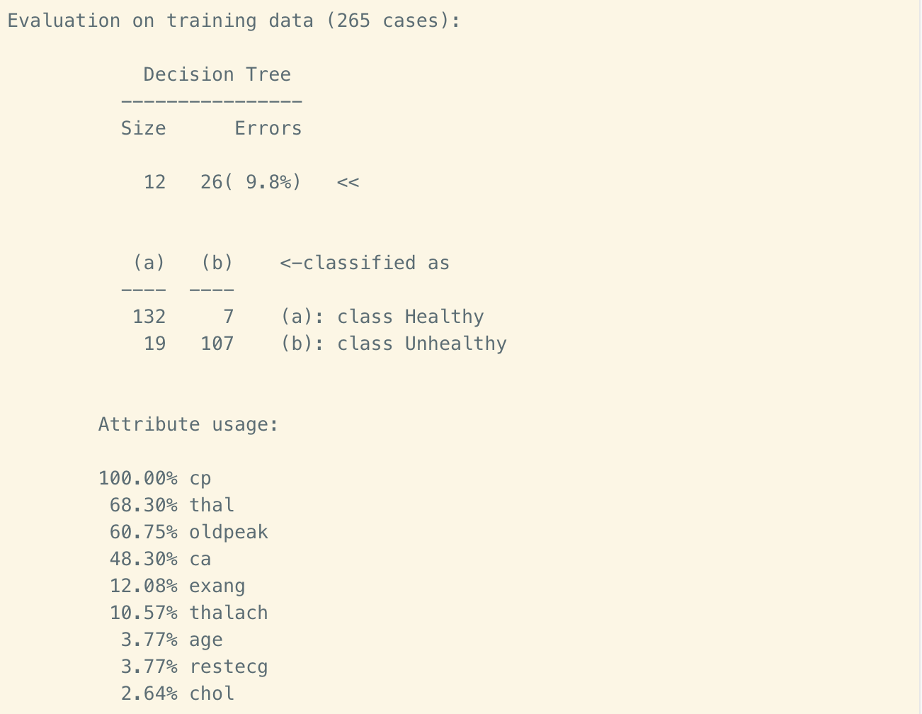
Figure 9. Decision tree summary
In this page we could see that the 90.2% of training data are correctly classified, which is impressive. The confusion matrix showing how the 9.8% errors allocated. The false positive is higher than false negative. We could also see the attribute level of all variables. cp, thal, oldpeak and ca are the 4 most affected variables in this model.

Step 3 – evaluating model performance
Now we apply the model to test data and get the performance review shown as below.
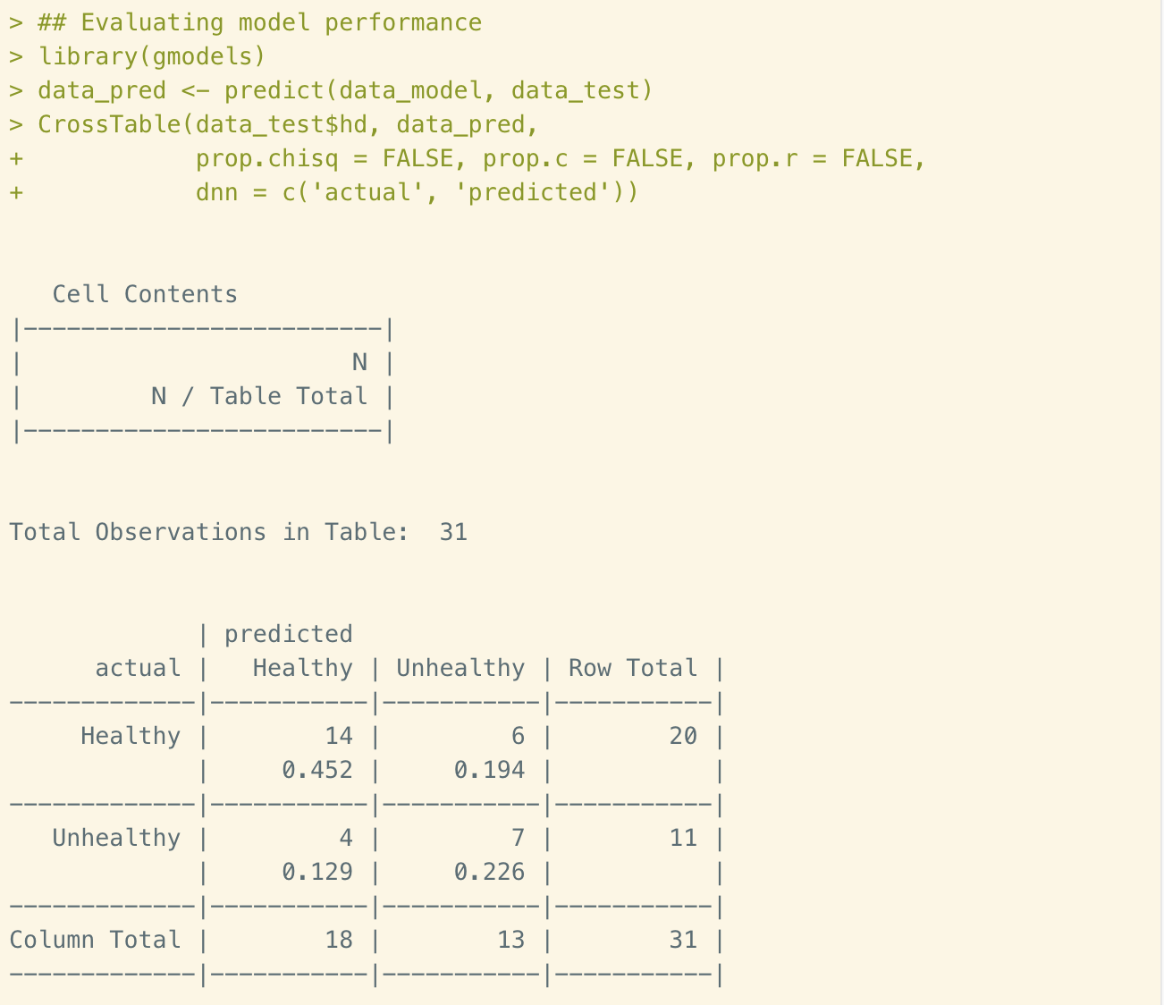
Figure 10. Decision tree performance evaluation
There are 31 observations in test data. The accuracy rate is about 68%, which is lower than training data. The false positive rate is 36%, which is relatively lower than false negative rate of 30%. Since the accuracy rate is low, this model needs to be improved.

Step 4 – improving model performance
Adaptive boosting is one of methods to improve the performance. This is an idea of considering that every model has a unique set of strengths to weakness the solving certain problems. So, we would like to complement these points by using a combination of several learners to increase the accuracy. To do that, we simply add an additional trials parameter to limit the upper number of trees when it realized that no more trials were necessary. Let’s try boost 10 vector and see what we would get.
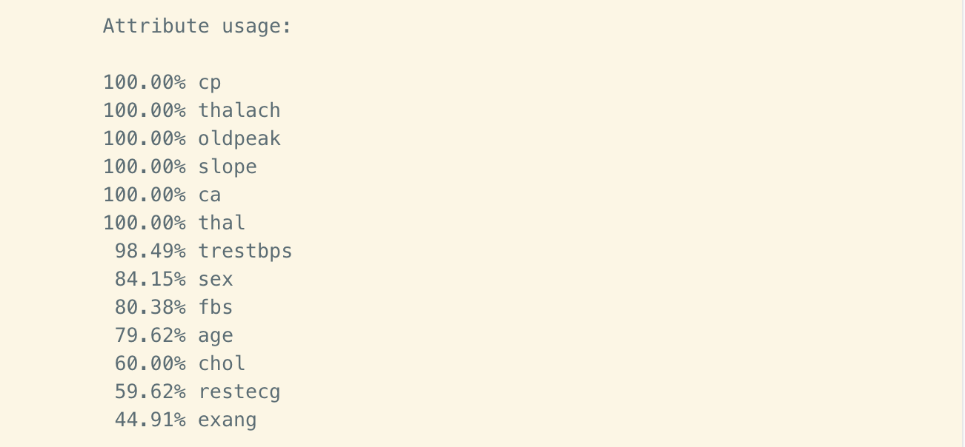
Figure 11. Attribute usage
This time there are more variables attributed in the model. Below is the confusion table.
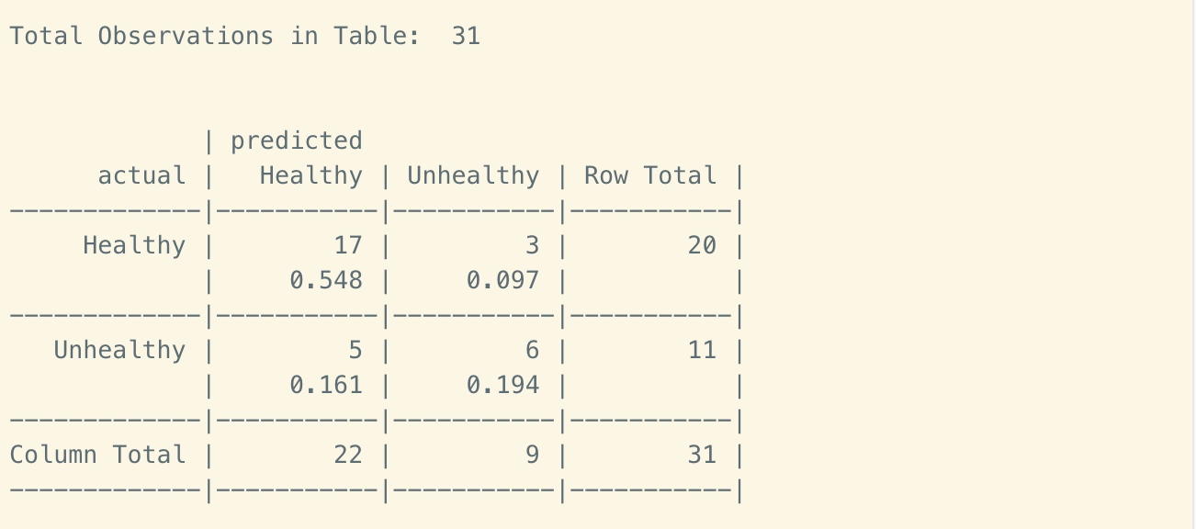
Figure 12. Boost10 confusion table

The result of this adjusted model performs slightly better of the original. The accuracy rate is now 74% rather than 68%. But still lower than expected.

Random Forests

Step 1 – training a model on the data
Now we are going to try another algorithm, Random forests. Different from Decision tree, Random forest generate all samples randomly, so we don’t need to split the original dataset into training data and test data. We could simply use the entire dataset for both training and test preposes.
We are going to use all of the 13 variables to train the model. The number of trees is going to remain 500. The number of variables for each internal node is set to 3. The trace of each evaluation is set to 100.
Set the seed for random number generator to reproduce our results since we are going to be randomly sampling data. Then we could build the forest using following function.
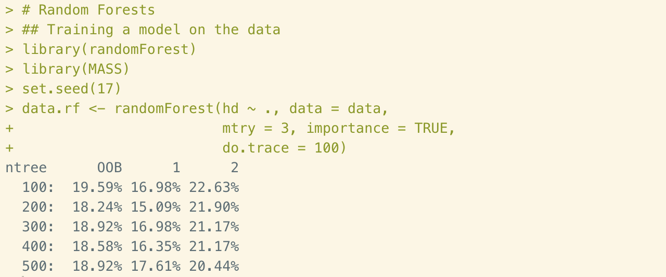
Figure 13. Training the model
The OOB (stands for Out-Of_Bag) error rate indicating that estimation is improving by decreasing trend as low as 18.52%. The stay about number meaning that the estimate is as good as they are going to get.

Step 2 – evaluating model performance
To evaluate the performance of the model, simply use print() function to get a confusion matrix shown as below:
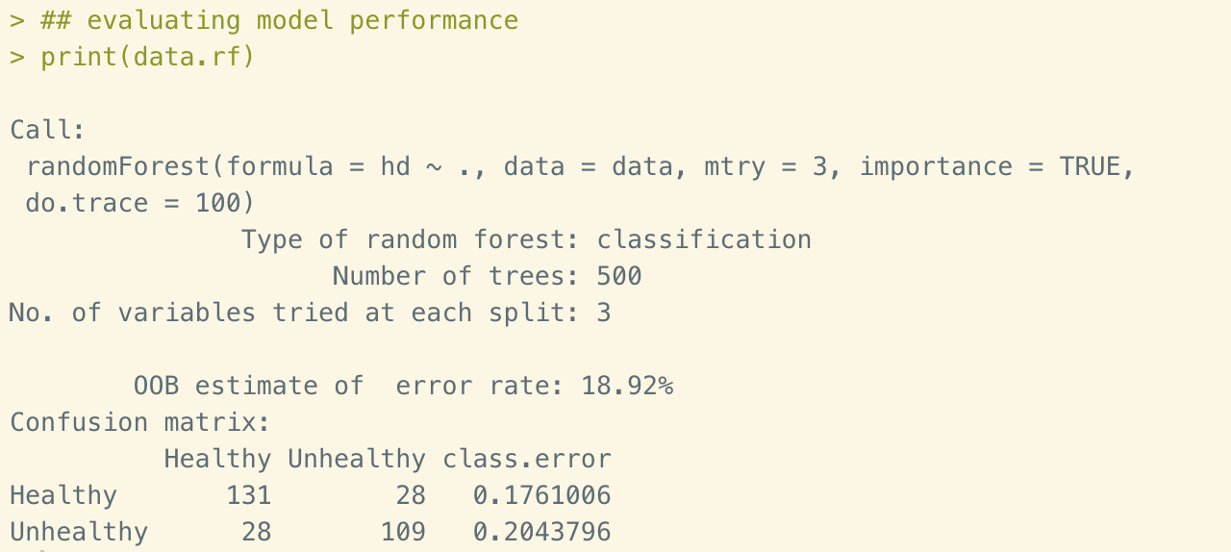
Figure 14. Model evaluation
The OOB error estimate of this model is 18.92%, which is much better than the result of Decision trees. The false positive rate is about 20%.

Step 3 – Random forest and SVM comparison
In this step, we are going to compare the random forest with support vector machines (SVM). We are going to use 10 times 10-fold cross-validation to generate a vector called error.SVM. All the variables will be considered with cost equals to 10 and gamma equals to 1.5.
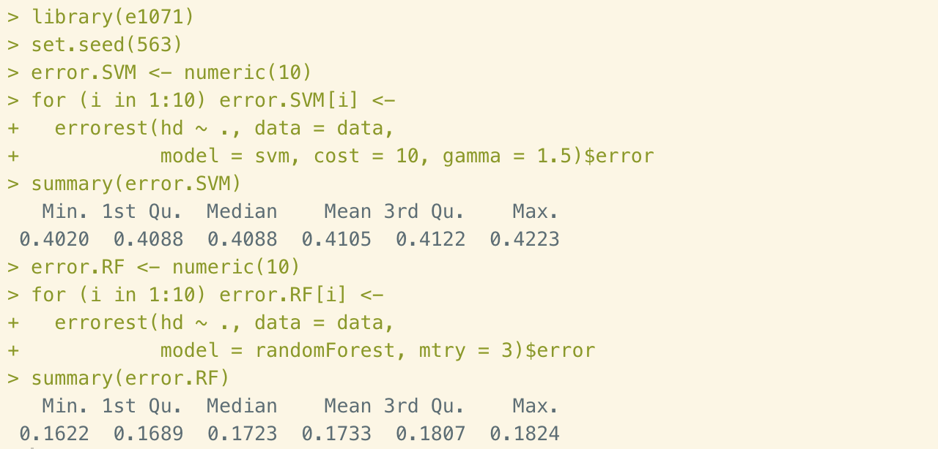
Figure 14. SVM vs. Random forest
From the two summaries we could see that Random forest returns much lower error rate than SVM. Therefore, the random forest compares favorably with SVM. So, the model of Random forest is better accepted in this case. The accuracy rate is 81.08%.

Logistic Model

Step 1 – training the logistic model and get the summary
After employ Decision trees and Random forest to the dataset, now let’s try our last algorithm in this report: Logistic model. We are going to create a model that uses all of the variables to predict heart disease and see the details from the summary() function.
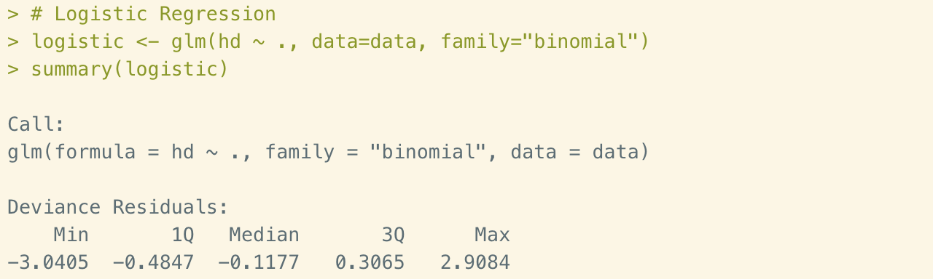
Figure 15. Logistic model formula and parcel summary
The first line has the original call to the glm() function. This formula syntax, hd ~ ., meaning all of the variables are considered. The second line gives a summary of the deviance residuals. They look good since they are close to being centered on 0 and are roughly symmetrical.
Then let’s take a look at some of the coefficients since the full page is so long.
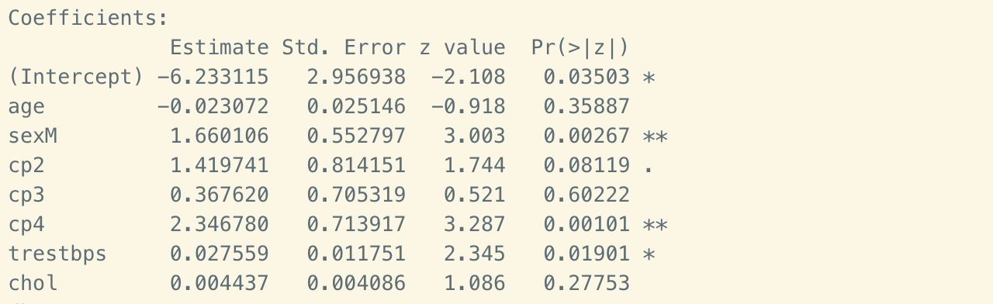
Figure 16. Coefficients
The p-value of age is 0.36, which is much higher than 0.05. This indicates age isn’t a useful predictor. The median age in our dataset was 56, so most of the folks were pretty old and that explains why it wasn’t very useful. Gender on the other hand, is a good predictor since the p-value is 0.00267. A small p-value alone isn’t interesting, we also want large effect sizes, and that’s what the log(odds) and log(odds ratio) tells us.

Step 2 – visualize the model
Next, let’s draw a graph that shows the predicted probabilities that each patient has heart disease along with their actual heart disease status using following code.
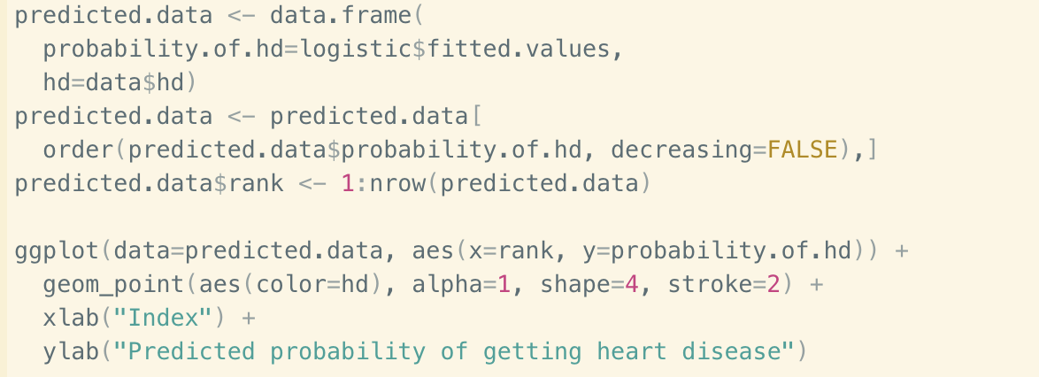
Figure 17. plot the model
Then we get a plot shown as below,
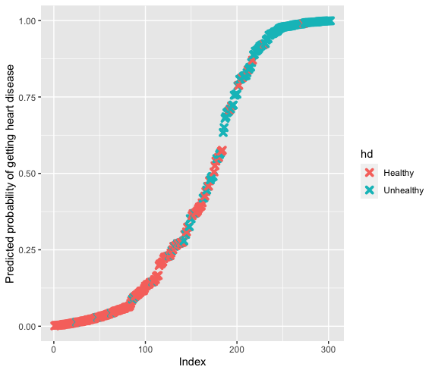
Figure 18. predicted plots

Most of the patients with heart disease in turquoise are predicted to have a high probability of having heart disease. And most of the patients without heart disease in pink are predicted to have a low probability of having heart disease. So, the logistic regression model has done a good job in prediction.

Step 3 – model evaluation
We could also sue cross-validation to get a better idea of how well it might perform with new data.
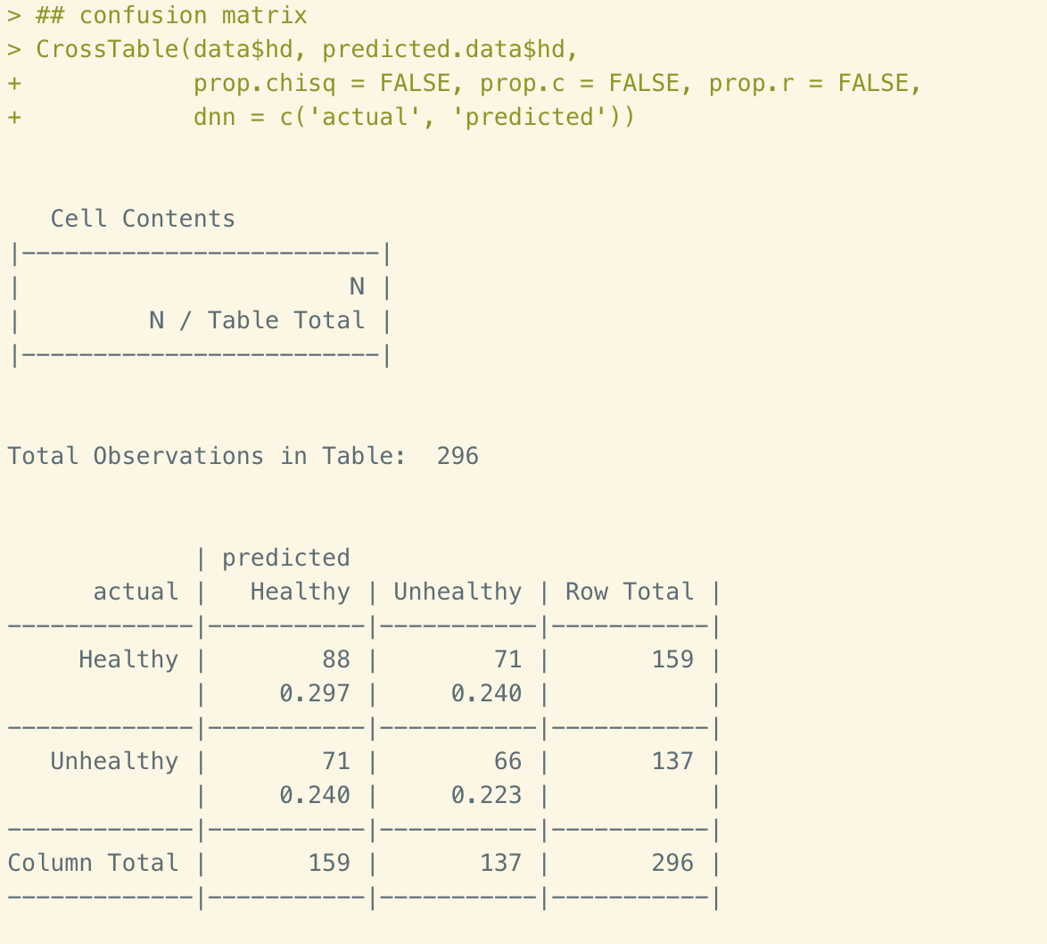
Figure 19. Confusion table
In confusion table above we could see that the accuracy rate of logistic regression is 52%. The false positive rate is over 50%.

Conclusions
In this report we practiced three classification methods, the Decision trees, Random forests, and Logistic regression model using the same data. We have choose these three methods out of the characteristic of our data. We used 13 variables to classify the status of heart disease whether the patient is healthy or unhealthy. In practice, healthy provider would spend lots of time to make diagnoses. With help from machine learning, the efficiency would be improved dramatically. After employing these three algorithms, we’ve got results of accuracy rate as 74%, 81%, and 52% respectively. Thus, the random forest could be a most accepted way to make the prediction.

Reference
- Lantz, B. (July 2015). Chapter 5: Divide and Conquer – Classification Using Decision Trees and Rules. In Machine Learning with R (2nd ed., pp. 125-169). Birmingham, UK: Packt Publishing.
- Strickland J. (July 2015). Chapter 7: Random forests. In Predictive Analytics using R (pp. 109-121). Colorado Springs, CO: Simulation Educators.
- Strickland J. (July 2015). Chapter 11: Generalized linear model. In Predictive Analytics using R (pp. 219-224). Colorado Springs, CO: Simulation Educators.
- Machine Learning Repository. (1988, July 01). Heart Disease Data Set [Data file]. Retrieved from http://archive.ics.uci.edu/ml/datasets/Heart+Disease

